How to use the New Data Search Tool
The Data Search tool is near the bottom of the www.lmi.mt.gov homepage. Hover over the Select a Category button to reveal the list of categories. Hovering over each selection will then reveal the list of sub-categories available. Click on the sub-category to be directed to the results page.
When the page first opens it will default to the state of Montana results (or U.S. if MT is not available). At the top of the results there is a series of filters that to choose from to customize your search. It is best to start with the filter furthest to the left and work to the right to make your choices, since previous filter choices can limit the choices available in subsequent filters.
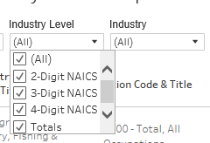
After each filter selection is made the results will update on the page. To reset the filters to show everything, click on the X at the end of the filters and all choices in each filter will be chosen.
Sorting Results
This tool will sort within the data header columns and the data columns in different manners. To find out which are the header columns and which are the data columns, hover over the column label and an icon next to the column name that shows 3 lines with an arrow pointing up or down will appear. Click on the icon to change the sort direction. Data columns will not show an icon when hovering over the heading.

Sorting with the heading columns will sort the information within the previous headings. In this case Industry code and title would be sorted by Area, Year and then Industry Code and Title. As an example, if US and Montana are chosen as the areas, then 2016 and 2015 as the years, the results would then be in 4 groupings: Montana-2015, Montana-2016, US-2015, and US-2016, then each of these groups would be sorted by the industry code and title.
A data column will not show the icon when hovering over it. To sort data within the data columns it is necessary to click on the column's label to highlight it and then right click to bring up the sort options box. Pick ascending or descending sort represented by the up and down arrows.
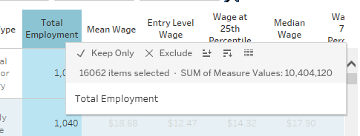
Highlighting will gray out the other data. To remove the highlight, click somewhere within the highlighted data to turn off the highlighting. It may be necessary to double click on the data to remove the highlighting.
Downloading your results
At the top right of the results area there is a download option. To download an image or pdf of the current page just click on the download button and choose image or pdf. To download the data as a text or crosstab text file click on the table without highlighting anything. Then click on download and the file format selections will show the additional options of data and crosstab.
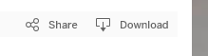
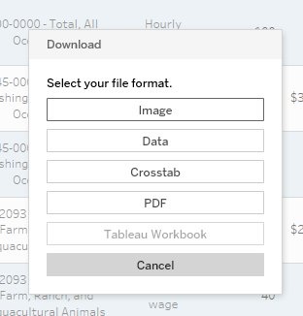
If data has been highlighted in the table, only the highlighted data will be downloaded.
When choosing to download data it will appear with 2 options- a Summary tab and the full data tab. The Summary tab will show the data in multiple rows for the same data. There will be a row for each of the data fields as seen in the following example. There is a row for the 25th percentile, 75th percentile, median wage, mean wage, entry level wage, and total employment.
The Full data tab will show the data as it appears in the results page, all fields in a single row instead of multiple rows for each record.

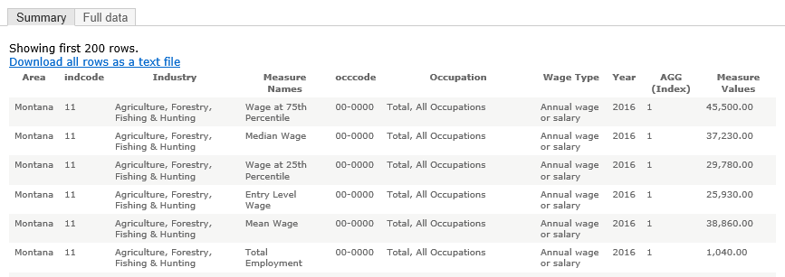
The crosstab option will create a text file in the full data format.

